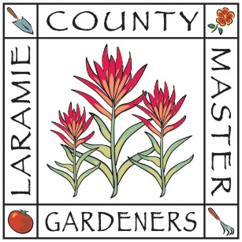
Laramie County Master Gardeners
P.O. Box 2540, Cheyenne, WY 82003-2540
lcmgardeners@wyoming.com
307-632-0678

Date:

TO WHOM IT MAY CONCERN:

PLEASE NOTE SUBMISSION DATE:

The Laramie County Master Gardeners organization has elected to seek out community projects which will reflect our objectives within Laramie County. Some of our projects include the Crevice Garden at the Cheyenne Botanic Gardens, the Memorial Park at the Archer Complex, the Pine Bluffs Columbarium, the microscope for the Boys and Girls Club, and the Laramie County Seed Library.

(The objective of LCMG is to educate youth and adults in horticulture, to promote civic beautification, to develop leadership and personal growth, and to assist the University of Wyoming Laramie County Extension Office in fulfillment of its horticulture mission in Laramie County, Wyoming. LCMG is organized exclusively for charitable, educational, and scientific purposes, including making distributions to organizations qualifying as exempt from federal income tax under section 501(c)(3) of the Internal Revenue Code, or corresponding section of any future federal tax code.)
The Laramie County Master Gardeners is desirous of one-time projects that we can commit to and that will be lasting. Our preference would be to complete a project within one year with no long-term maintenance or financial support beyond the project’s completion. We will place signage (plaque/plaques) notating our involvement in the project. All submitted projects will be considered, going through the levels of our Committee, Executive Board, and final Membership approval.
If you have any ideas or needs that you would like to have our organization consider, please
complete the attached form and return it to us as soon as possible.

Sincerely,

Sharyn Guthridge , Chair
Legacy Project Committee

